**Lab Assignment – 3**

***Deploying NodeJS application in GCP VM***

*19CSE445 – Cloud Computing*

**HTML with CSS:**

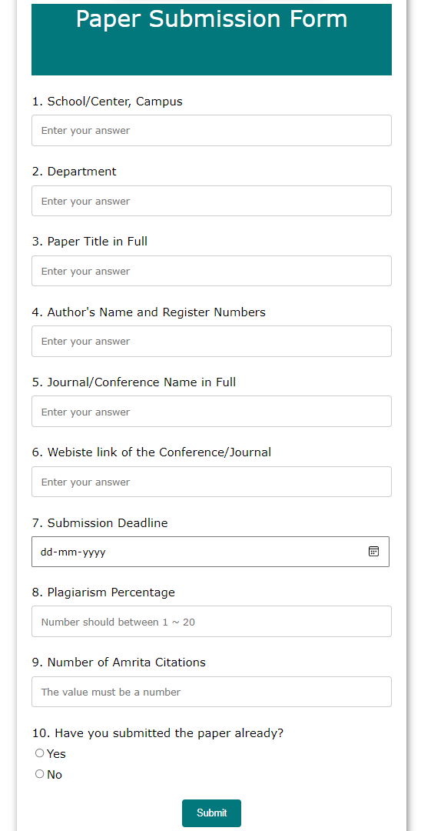

**Loading HTML file (client side):**

* 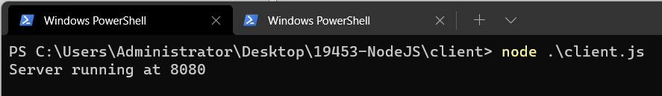
* 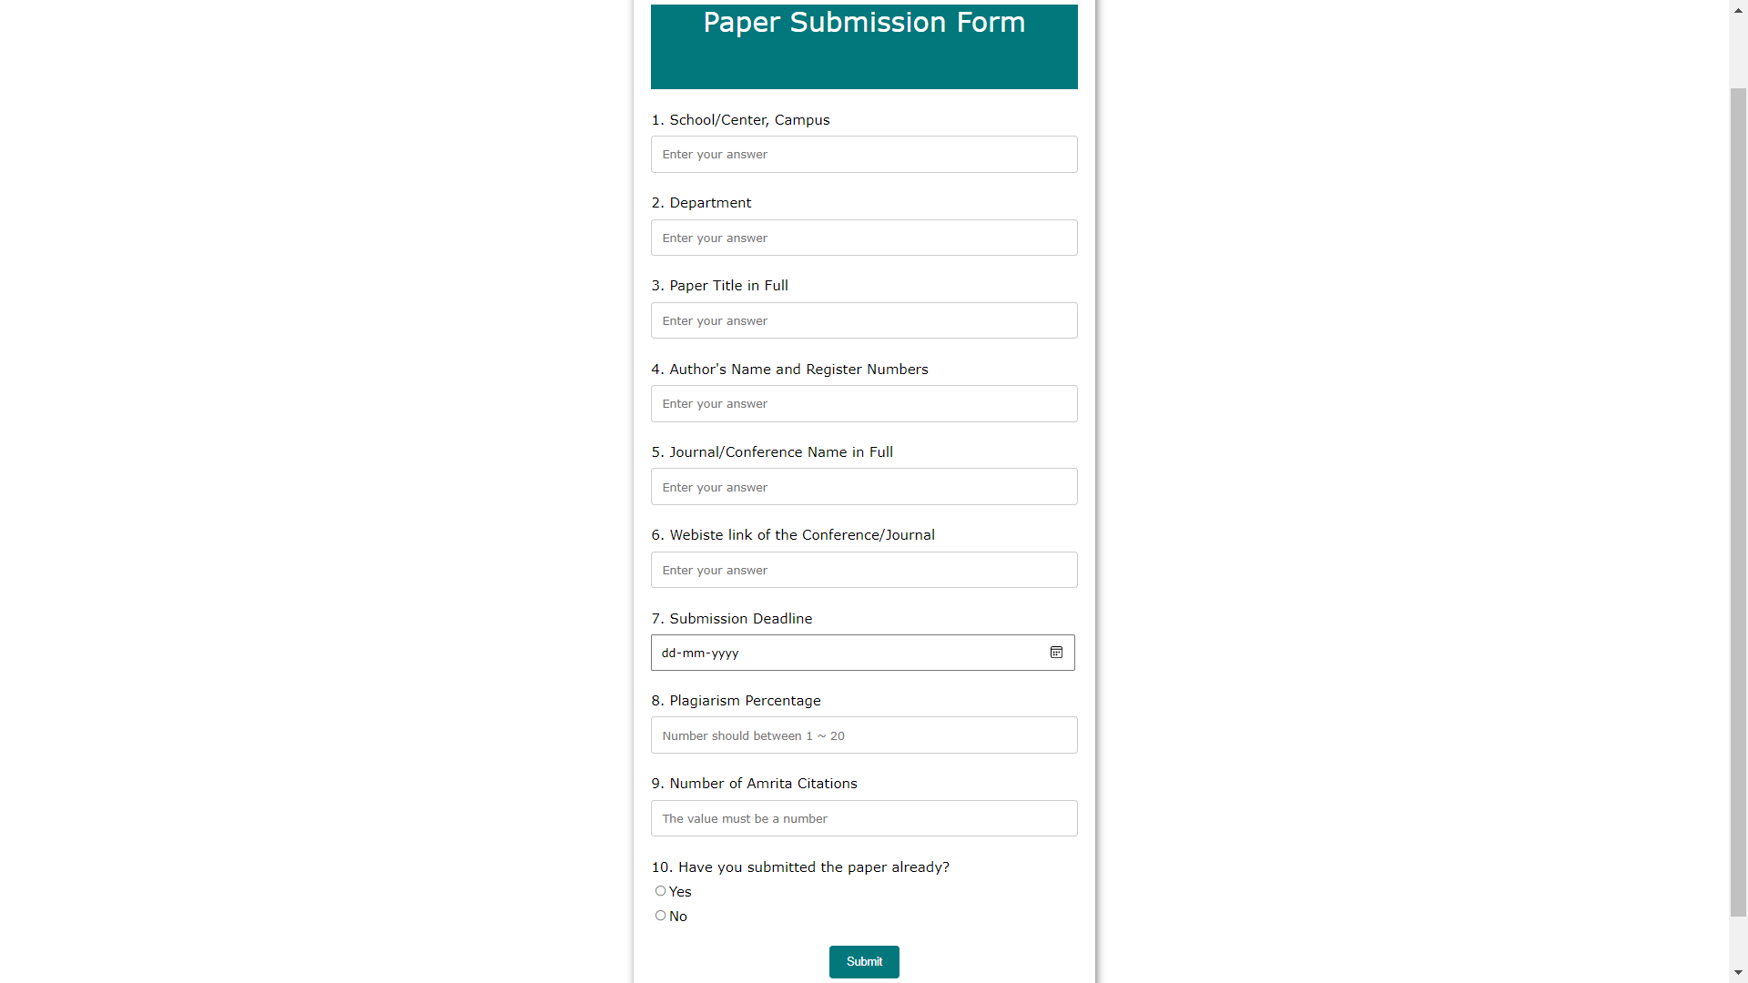

**Validation JS file (Server side):**

* 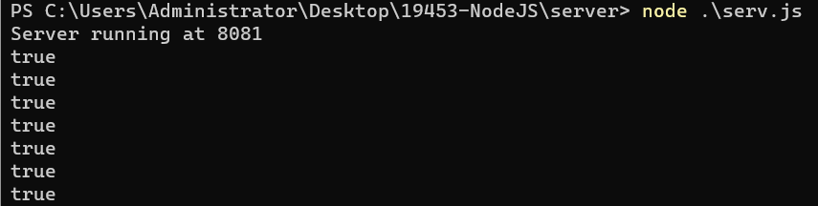

**If form is empty, validation page shows:**

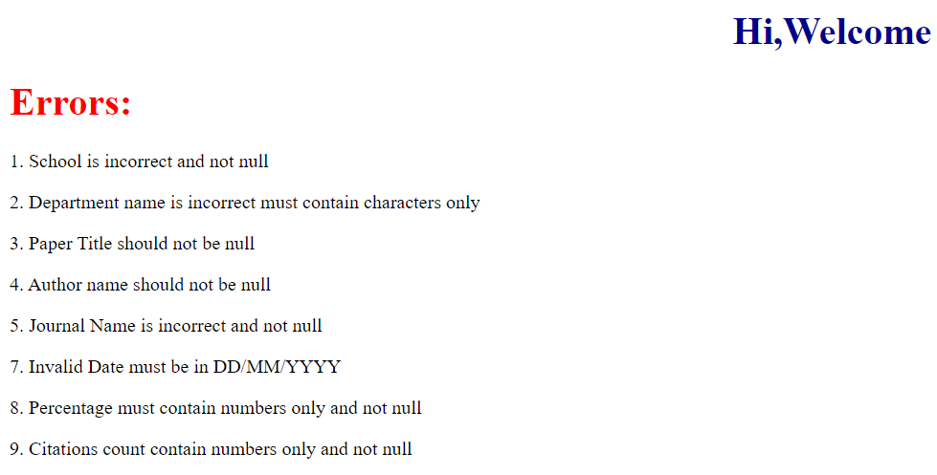

**Case(i): First 5 fields entered**

* 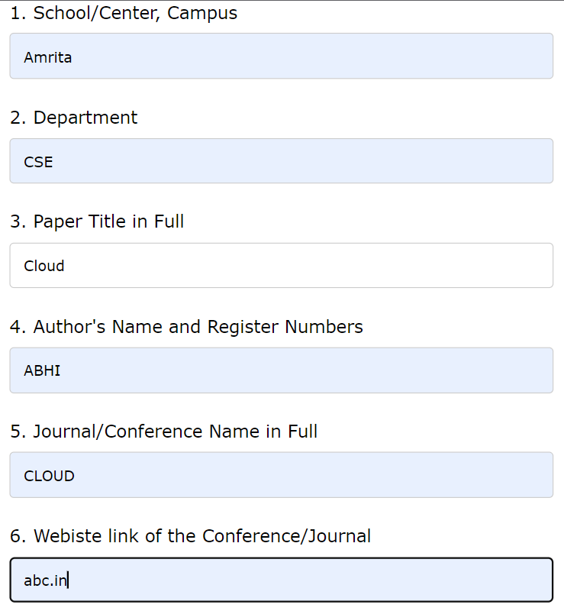
* **Errors:**

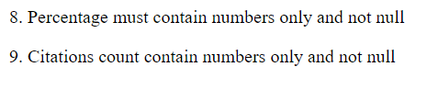

**HTML:**

<!DOCTYPE html>  
<html lang="en">  
  
<head>  
 <meta charset="UTF-8">  
 <meta http-equiv="X-UA-Compatible" content="IE=edge">  
 <meta name="viewport" content=  
 "width=device-width, initial-scale=1.0">  
 <title>  
 Abhinav  
 </title>  
  
 <style>  
 body {  
 background-color: white;  
 font-family: Verdana;  
 text-align: center;  
 }  
  
 form {  
 background-color: #fff;  
 max-width: 500px;  
 margin: 50px auto;  
 padding: 20px 20px;  
 box-shadow: 2px 5px 10px rgba(0, 0, 0, 0.5);  
 }  
  
 .form-control {  
 text-align: left;  
 margin-bottom: 25px;  
 }  
  
 .form-control label {  
 display: block;  
 margin-bottom: 10px;  
 }  
  
 .form-control input,  
 .form-control select,  
 .form-control textarea {  
 border: 1px solid #777;  
 border-radius: 2px;  
 font-family: inherit;  
 padding: 10px;  
 display: block;  
 width: 95%;  
 }  
  
 .form-control input[type="radio"],  
 .form-control input[type="checkbox"] {  
 display: inline-block;  
 width: auto;  
 }  
 input[type=text], select, textarea {  
 width: 100%;  
 padding: 12px;  
 border: 1px solid #ccc;  
 border-radius: 4px;  
 box-sizing: border-box;  
 margin-top: 6px;  
 margin-bottom: 16px;  
 resize: vertical;  
 }  
  
 input[type=submit] {  
 background-color: #03787c;  
 color: white;  
 padding: 12px 20px;  
 border: none;  
 border-radius: 4px;  
 cursor: pointer;  
 }  
  
 input[type=submit]:hover {  
 background-color: #03787c;  
 }  
 </style>  
</head>  
  
<body>  
<!-- Create Form -->  
<form action="http://localhost:8081" method="GET" id="form">  
  
 <!-- Details -->  
 <div class="form-control" style="background-color:#03787c; color: white; height: 100px; width: 100%; font-size:xx-large">  
 <p align="center">Paper Submission Form</p>  
 </div>  
  
 <div class="form-control">  
 <label for="name" id="label-name">  
 1. School/Center, Campus  
 </label>  
  
 <!-- Input Type Text -->  
 <input type="text"  
 id="name"  
 placeholder="Enter your answer" />  
 </div>  
  
 <div class="form-control">  
 <label for="email" id="label-email">  
 2. Department  
 </label>  
  
 <!-- Input Type Email-->  
 <input type="text"  
 id="dept"  
 placeholder="Enter your answer" />  
 </div>  
  
 <div class="form-control">  
 <label for="age" id="label-age">  
 3. Paper Title in Full  
 </label>  
  
 <!-- Input Type Text -->  
 <input type="text"  
 id="title"  
 placeholder="Enter your answer" />  
 </div>  
 <div class="form-control">  
 <label for="age" id="label-age">  
 4. Author's Name and Register Numbers  
 </label>  
  
 <!-- Input Type Text -->  
 <input type="text"  
 id="author"  
 placeholder="Enter your answer" />  
 </div>  
 <div class="form-control">  
 <label for="age" id="label-age">  
 5. Journal/Conference Name in Full  
 </label>  
  
 <!-- Input Type Text -->  
 <input type="text"  
 id="journal"  
 placeholder="Enter your answer" />  
 </div>  
 <div class="form-control">  
 <label for="age" id="label-age">  
 6. Webiste link of the Conference/Journal  
 </label>  
  
 <!-- Input Type Text -->  
 <input type="text"  
 id="link"  
 placeholder="Enter your answer" />  
 </div>  
 <div class="form-control">  
 <label for="age" id="label-age">  
 7. Submission Deadline  
 </label>  
  
 <!-- Input Type Text -->  
 <input type="date"  
 id="deadline"  
 placeholder="Enter your answer" />  
 </div>  
 <div class="form-control">  
 <label for="age" id="label-age">  
 8. Plagiarism Percentage  
 </label>  
  
 <!-- Input Type Text -->  
 <input type="text"  
 id="percentage"  
 placeholder="Number should between 1 ~ 20" />  
 </div>  
 <div class="form-control">  
 <label for="age" id="label-age">  
 9. Number of Amrita Citations  
 </label>  
  
 <!-- Input Type Text -->  
 <input type="text"  
 id="number"  
 placeholder="The value must be a number" />  
 </div>  
  
  
 <div class="form-control">  
 <label>  
 10. Have you submitted the paper already?  
 </label>  
  
 <!-- Input Type Radio Button -->  
 <label for="recommed-1">  
 <input type="radio"  
 id="recommed-1"  
 name="recommed">Yes</input>  
 </label>  
 <label for="recommed-2">  
 <input type="radio"  
 id="recommed-2"  
 name="recommed">No</input>  
 </label>  
 </div>  
  
 <input type="submit" value="Submit">  
</form>  
</body>  
  
</html>

**Client.js (Accessing html file thorugh server):**

var http = require("http");  
var path = require("path");  
var fs = require('fs');  
  
http.createServer(function (req, res) {  
 fs.readFile(__dirname + '/index.html', function (err,data) {  
 if (err) {  
 res.writeHead(404);  
 res.end(***JSON***.stringify(err));  
 return;  
 }  
 res.writeHead(200);  
 res.end(data);  
 });   
}).listen(8080);  
  
// Console will print the message  
***console***.log('Server running at 8080');

**Server.js (Validation of added record):**

var http = require("http");  
var gow = require("url");  
  
http  
 .createServer(function (request, response) {  
 response.writeHead(200, { "Content-Type": "text/html" });  
 var q = gow.parse(request.url, true).query;  
 ***console***.log("true");  
 let id = q.name;  
 let empName = q.dept;  
 let title = q.title;  
 let author = q.author;  
 let journal = q.journal;  
 let link = q.link;  
 let dead = q.deadline;  
 let percent = q.percent;  
 let num = q.number;  
 var numbers = /^[0**-**9]*$/;  
 var letters = /^[a**-**zA**-**Z]*$/;  
 var date_regex = /^(0[1**-**9]|1[0**-**2])**\/**(0[1**-**9]|1\d|2\d|3[01])**\/**(19|20)\d{2}$/;  
 var email_val = /^([a**-**zA**-**Z0**-**9_\.\-])+\@(([a**-**zA**-**Z0**-**9\-])+\.)+([a**-**zA**-**Z0**-**9]{2,4})+$/;  
 var txt = "Welcome " + q.name;  
 var dummy = "Errors: ";  
 response.write('<h1 style="color:darkblue" align="center">Hi,' + txt+'</h1>');  
 response.write('<h1 style="color:red"> \t' + dummy+'</h1>');  
  
 function validatedate(inputText,DateFormat)  
 {  
 // format dd/mm/yyyy or in any order of (dd or mm or yyyy) you can write dd or mm or yyyy in first or second or third position ... or can be slash"/" or dot"." or dash"-" in the dates formats  
 var invalid = "";  
 var dt = "";  
 var mn = "";  
 var yr = "";  
 var k;  
 var delm = DateFormat.includes("/") ? "/" : ( DateFormat.includes("-") ? "-" : ( DateFormat.includes(".") ? "." : "" ) ) ;  
 var f1 = inputText.split(delm);  
 var f2 = DateFormat.split(delm);  
 for(k=0;k<=2;k++)  
 {  
 dt = dt + (f2[parseInt(k)]=="dd" ? f1[parseInt(k)] : "");  
 mn = mn + (f2[parseInt(k)]=="mm" ? f1[parseInt(k)] : "");  
 yr = yr + (f2[parseInt(k)]=="yyyy" ? f1[parseInt(k)] : "");  
 }  
 var mn_days = "0-31-" + (yr % 4 == 0 ? 29 : 28) + "-31-30-31-30-31-31-30-31-30-31";  
 var days = mn_days.split("-");  
 if( f1.length!=3 || mn.length>2 || dt.length>2 || yr.length!=4 || !(parseInt(mn)>=1 && parseInt(mn)<=12) || !(parseInt(yr)>=parseInt(1900) && parseInt(yr)<=parseInt(2100)) || !(parseInt(dt)>=1 && parseInt(dt)<=parseInt(days[parseInt(mn)])) )  
 {  
 invalid = "true";  
 }  
 alert( ( invalid=="true" ? "Invalid Date" : "Valid Date") );  
 }  
  
 if (!(id !== "" && id !== undefined && id.match(letters))) {  
 response.write(  
 "<p>1. School is incorrect and should not be null</p>"  
 );  
 }  
 if (  
 !(empName !== "" && empName !== undefined && empName.match(letters))  
 ) {  
 response.write("<p>2. Department name is incorrect must contain characters only</p>");  
 }  
 if (!(title !== "" && title !== undefined && title.match(letters))) {  
 response.write(  
 "<p>3. Paper Title should not be null</p>"  
 );  
 }  
 if (!(author !== "" && author !== undefined && author.match(letters))) {  
 response.write(  
 "<p>4. Author name should not be null</p>"  
 );  
 }  
 if (!(journal !== "" && journal !== undefined && journal.match(letters))) {  
 response.write(  
 "<p>5. Journal Name is incorrect and not null</p>"  
 );  
 }  
 if (!(date_regex.test(dead))) {  
  
 response.write(  
 "<p>7. Invalid Date must be in DD/MM/YYYY</p>"  
 );  
 }  
  
 if (!(percent !== "" && percent !== undefined && percent.match(numbers))) {  
 response.write(  
 "<p>8. Percentage must contain numbers only and not null</p>"  
 );  
 }  
  
 if (!(num !== "" && num !== undefined && num.match(numbers))) {  
 response.write(  
 "<p>9. Citations count contain numbers only and not null</p>"  
 );  
 }  
  
 response.end();  
 })  
 .listen(8081);  
// Console will print the message  
***console***.log('Server running at 8081');

**Q1. ✅**

**Q2. ✅**

**Q3.**

**SSH key gen:**

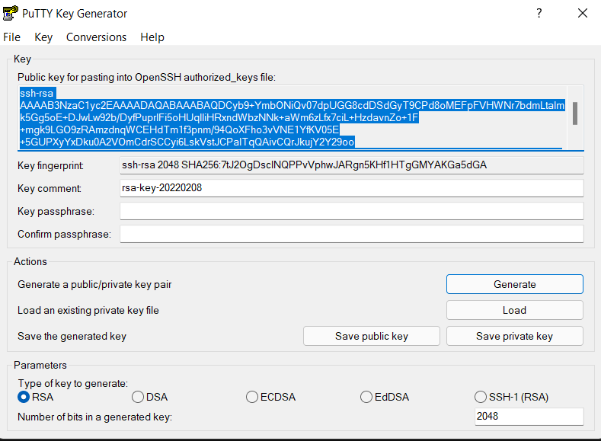

**Mapping local computer to VM:**

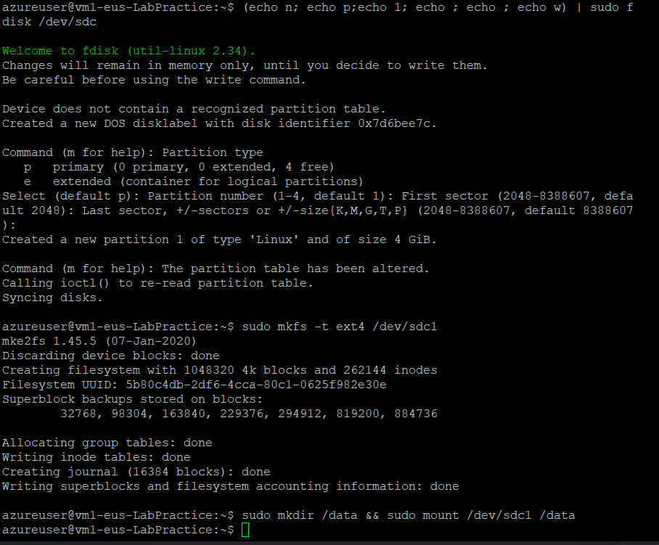

**Configuring Ports in VM:**

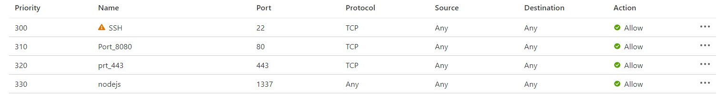

**Deploying NodeJS in VM:**

* 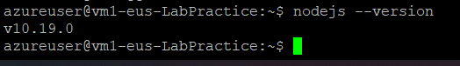
* 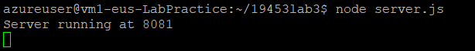

**Configuring unique DNS:**



**Link:** [**abhinavcloud.eastus.cloudapp.azure.com**](abhinavcloud.eastus.cloudapp.azure.com)

**Screenshot:**

